Block of the Month for July

OLD GLORY STAR

Heart and Flag combine to express our patriotism in this red, white and blue July Block of the Month. Try to think “American Flag” when you choose the colors for your block.

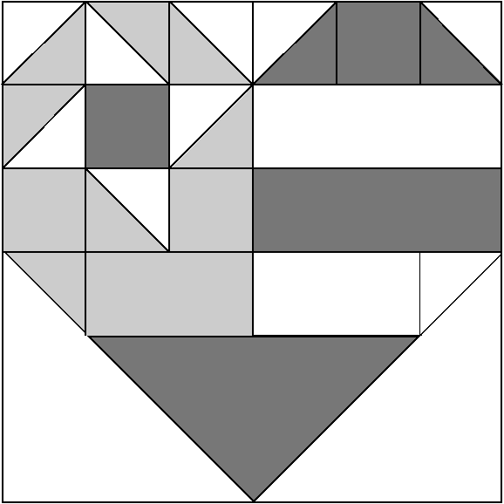
White fabric

Red fabric

Blue fabric

CUTTING:
Cut 2 red and 2 blue 2 ½” squares.
Cut 1 red and 1 white 2 ½” x 6 ½” rectangles.
Cut 1 blue and 1 white 2 ½” x 4 ½” rectangles.
Cut 4 blue, 1 red and 5 white 2 7/8” squares.
Cut 1 white 6 7/8” square.
Cut 1 red 9 ¼” square.

ASSEMBLY:
Place 3 blue and white 2 7/8” squares right sides together. Draw a diagonal line across the wrong side of the white squares. Stitch ¼” on each side of the diagonal line. Cut on the diagonal line. Place 1 red and white square right sides together. Draw a diagonal line across the white square. Stitch ¼” on each side of the diagonal line. 8 half square triangles made. Press them open.

Draw a diagonal line across the wrong side of a white and blue 2 7/8” square. Cut on the line. Discard ½ of each. Draw a diagonal line on the wrong side of the white 6 7/8” square. Cut on the diagonal line. Draw 2 diagonal lines (an X) on the red 9 ¼” square. Cut on the diagonal lines. Keep one triangle. Discard the other 3.

Following the diagram, stitch the first 4 rows of pieces together. Sew the red triangle onto the fourth row. Sew the white triangles on last. You should now have a 12 ½” block.

Kika Hutchings

